ANNUAL EXAMINATION (2024-25)

DATE - 14 / 02 / 2025 CLASS – IX (APTITUDE) MM – 25
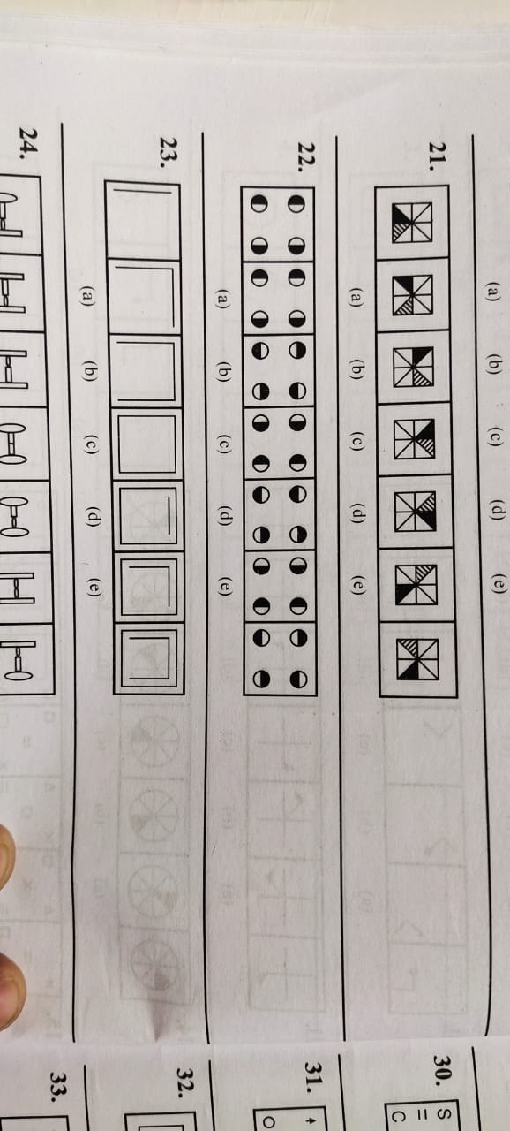
General Instructions
Section A: Each question carriers one marks Q1 to 17 - MCQ Based questions
Section B: Each question carriers two marks Q18 to 21- solution based questions.

Que. 1 Find odd one out

Directions (2-4) : Read the following information to answer the question based on it. Seven letters are arranged in a line as follows.
(i) E and F have one letter between them.
(ii) G is the right of A.
(iii) B is to the immediate left of F.
(iv) There is one letter between D and A.
(v) D is not G's neighbour. 6. G and F have two letters between.
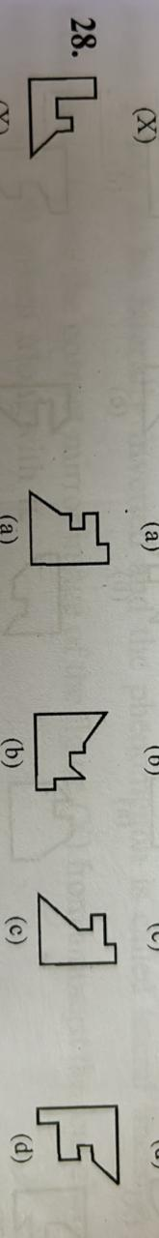
Que. 2 Which letter is second to the left of letter A?
(a) C (b) B (c) D (d) E
Que.3 Second Which letter will be exactly in the middle of the letter series so obtained?
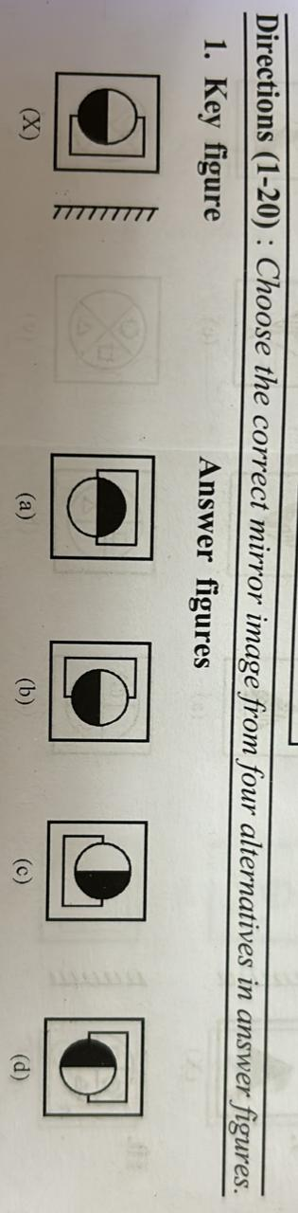
(a) D (b) A (c) E (d) G
Que. 4 Which pair of the letter is adjacent to the letter B?
(a) A and C (b) E and G (c) E and F (d) C and A
Que. 5.Construction of Square
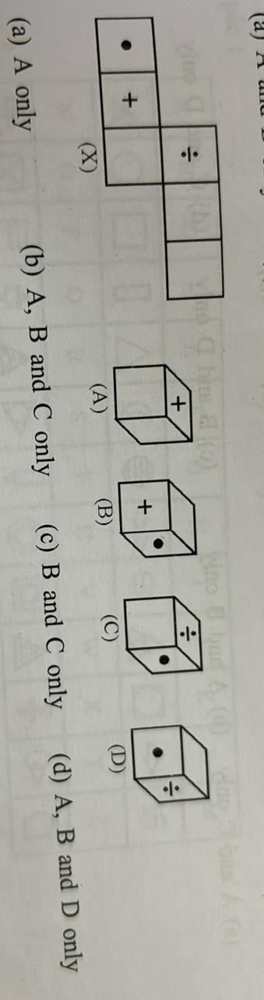

Que. 6 Correct Mirror Image

Que. 7 The figure given below is the unfolded position of cubical dice. This unfolded figure is followed by four different figures of dice. You have to select the figure which is identical to the figure.

(a) A only (b) A,B and C only (c) B and C only (d) A, B and D only

Que. 8 to 12 Fill the spaces with appropriate symbol in the words given on each question.

Que. 8 INT ……LL…..GENT
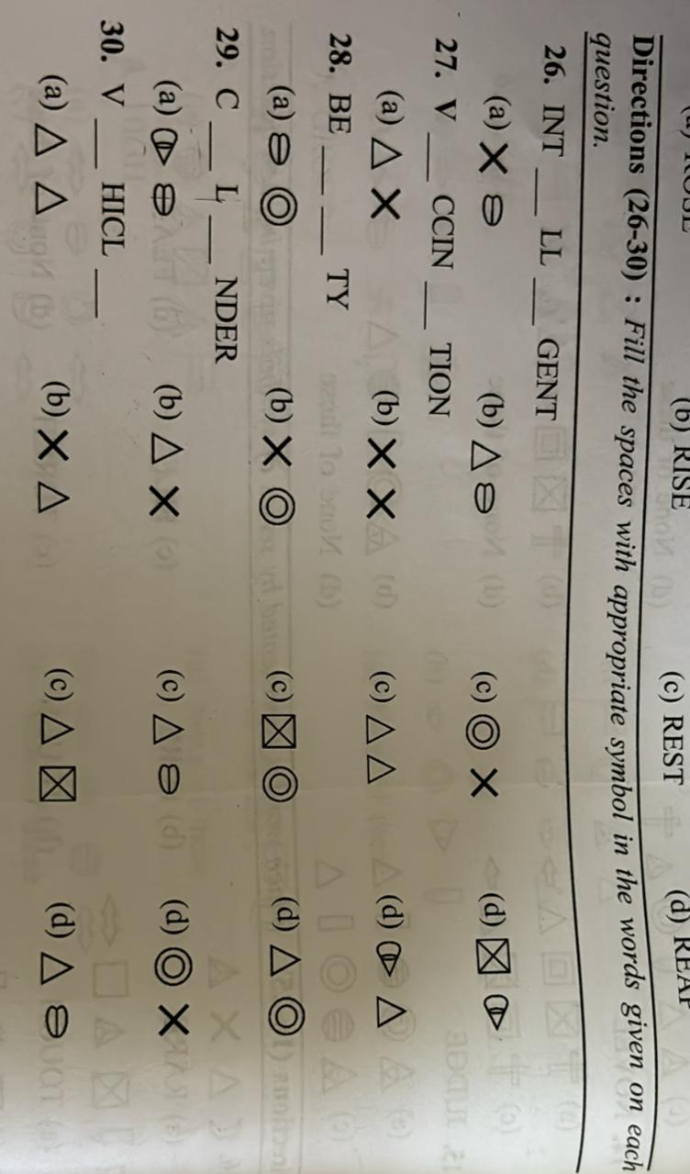
Que. 9 V…………CCIN………..TION
Que. 10 BE…… …….TY
Que. 11 C……..L……..NDER
Que. 12 V…………HICL………..
Que. 13 Venial
(a) Contagious (b) Filthy (c) Worthless (d) Excusable
Que. 14 If $-$ means $÷, + means ×, ÷means-, ×means+,$then which of the following equation is correct?
(a) 52 $÷$4 + 5 $×$8 - 2 =36 (b) 43 $×$7$÷$ 5 + 4 - 8 = 35
(c) 36 $×$ 4 - 12 + 5$÷$ 3 = 42 (d) 36 - 12 $×$6$÷$ 3 + 4 = 22
Direction (15 to 17) In a certain code the symbol for 0 (zero) is * and for 1 it is $∘$ there are no other
Symbols for other numbers and all numbers greater than 1 are written using these two symbols only. The value of the symbol 1 doubles itself every time it shifts one place to left thus
‘0’ is written as * ‘1’ is written as $∘$ ‘2’ is written as $∘$ *
‘3’ is written as $∘ ∘$ ‘4’ is written as $∘$* *
Que. 15 If $∘ ∘ ∘$ is added to $∘$* *, what will be the sum ?
(a) * * $∘ ∘$ (b) $∘ * ∘ ∘$ (c) $* ∘ ∘ *$ (d) $∘ * ∘ * ∘$
Que. 16 Which of the following represent 15?
- * $∘ ∘$ * * (b) $* ∘ ∘ * ∘$ (c) $∘ ∘ ∘ ∘$ (d) $* * ∘ ∘$
Que. 17 If is divided by , what will be the result?
(a) * $∘ ∘$ (b) $* ∘ ∘ *$ (c) $* * ∘ ∘$ (d) None
Que. 18 My age become half that of my brother's if we simply add 2years to his present age. If I am 25 years old today, my brother will be
Que. 19 Ratio of Rajendra’s age to Somesh’s is equal to 4:3. If Rajendra will be 26 years old after 6 years, the present age of Somesh is..
Que. 20 Find the cost of digging a pit 8 m long, 6m broad and 3m deep at the rate of rs. 100/m³
Que. 21 If x = 2 + $\sqrt{3}$, then x + $\frac{1}{x}$ is

